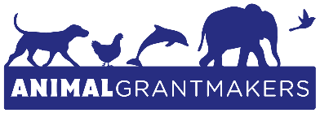
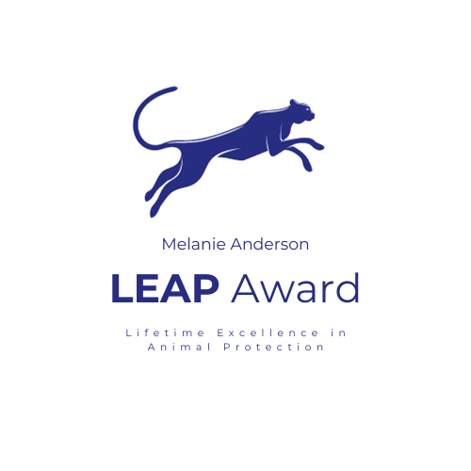

EMBARGOED UNTIL OCTOBER 24, 2023

Lynn Cuny Receives 2nd Annual Animal Grantmakers Melanie Anderson Lifetime Excellence in Animal Protection Award

Founder of Wildlife Rescue & Rehabilitation Honored at 2023 Animal Grantmakers Conference for Helping Wild and Domestic Animals for Over 45 Years and Counting

Philadelphia (October 24, 2023) – Animal Grantmakers, the nation’s only group of philanthropic funders focused on protecting and enabling the wellbeing of all animals, presented the 2nd Annual Animal Grantmakers Melanie Anderson Lifetime Excellence in Animal Protection Award (Melanie Anderson LEAP Award) to Lynn Cuny, founder and president of Wildlife Rescue & Rehabilitation in Texas (San Antonio and Kendalia), today during its 24th Annual Conference at the Sofitel Philadelphia at Rittenhouse Square.

The Melanie Anderson LEAP Award was established by the Summerlee Foundation and Animal Grantmakers in 2022 to honor Melanie Anderson, a lifelong animal protection advocate and the Summerlee Foundation’s director of animal programs for 32 years. Geared toward lifetime achievement, an award recipient’s body of work reflects a significant impact on non-human animals, especially those widely viewed as among the most overlooked, underfunded, heavily exploited, and in greatest need of support.

Recognizing animal advocates who have made a substantial and sustained contribution to the field of animal protection, Cuny was chosen as the 2023 Melanie Anderson LEAP Award winner for dedicating her professional and personal life to helping wild and domestic animals in need of safe and humane rehabilitation and sanctuary, as well as advocating for the humane and respectful care of animals, for over 45 years. In 1977, while in her early twenties, Cuny founded Wildlife Rescue & Rehabilitation in her San Antonio, Texas backyard. She saw that many wild animals who suffered and died after encounters with humans could have been saved and, with help, returned to the wild. She also saw that some wild animals could not be released due to the nature of their injuries (or other factors), but could live satisfactory lives in a sanctuary.

As of 2001, Wildlife Rescue & Rehabilitation’s primary base of operations has been 212 acres near Kendalia, Texas. Since its inception, the 501(c)(3) non-profit organization has received more than 200,000 native wild animals. Annually, it rescues over 10,000 animals, and responds to more than 17,000 phone inquiries and requests for help. Over 500 animals are permanent residents because they are non-releasable due to the nature of their injuries, human desensitization, or are non-native species. Accredited by the Global Federation of Animal Sanctuaries (GFAS), Wildlife Rescue & Rehabilitation employs approximately 50 full-time staff, who, along with interns, apprentices, and numerous volunteers, carry out its programs every day.

“I have long believed that one of the world’s great tragedies is the lack of understanding and respect shown to the countless animals who inhabit this Earth,” said Cuny during her acceptance remarks. “It was this, and my own compelling need to help them, that moved me to start an organization that works diligently to save the injured, orphaned, and other animals who were all too often ignored. I am sincerely grateful to be chosen as a recipient of the Animal Grantmakers Melanie Anderson LEAP Award, which also reminds me that one is never alone in the critically important commitment to the protection of all animals.”

Cuny worked diligently for years to encourage and assist sanctuaries in improving their direct care of animals. During this time, she conducted site visits and helped many sanctuaries raise their standards of care. Cuny is also the author of “Through Animals’ Eyes: True Stories from a Wildlife Sanctuary,” published in 1999, and the sequel, “Through Animals’ Eyes, Again: Stories of Wildlife Rescue,” published in 2006.

“The Melanie Anderson LEAP Award embodies a major concern of the Summerlee Foundation’s founder, Annie Lee Roberts, who sought out and embraced animal advocates who pushed boundaries, changed the conversation, and advocated for species and creatures often neglected or overlooked,” said Larry Green, Board president of Animal Grantmakers. “We are sure that Ms. Roberts would have been proud of Lynn Cuny for spending the majority of her life in the challenging field of animal protection, her huge accomplishments on behalf of animals to date, and for showing every animal, whether he or she is a jaguar or a pigeon, the same compassion and respect.”

Made possible by a grant from the Summerlee Foundation, Cuny was honored with a $2,000 prize and an engraved crystal award memorial.

About the Animal Grantmakers Melanie Anderson Lifetime Excellence in Animal Protection Award
Animal Grantmakers gives the Animal Grantmakers Melanie Anderson Lifetime Excellence in Animal Protection Award (Melanie Anderson LEAP Award) every fall at Animal Grantmakers’ Annual Conference to an animal advocate who has made a substantial and sustained contribution to the field of animal protection. Geared toward lifetime achievement, the recipient’s body of work reflects a significant impact on non-human animals, especially those widely viewed as among the most overlooked, underfunded, heavily exploited, and in greatest need of support.

The award was established by the Summerlee Foundation and Animal Grantmakers in summer 2022 to honor Melanie Anderson, a lifelong animal protection advocate and the Summerlee Foundation’s director of animal programs for 32 years. The Melanie Anderson LEAP Award embodies a major concern of the Summerlee Foundation’s founder, Annie Lee Roberts, who sought out and embraced animal advocates who pushed boundaries, changed the conversation, and advocated for species and creatures often neglected or overlooked.

Made possible by an annual grant from the Summerlee Foundation, winners of the Melanie Anderson LEAP Award receive an unrestricted $2,000 prize and an award memorial. Candidates are nominated by members of Animal Grantmakers and the winner is chosen by Animal Grantmakers’ Annual Conference Committee.

About Animal Grantmakers
Animal Grantmakers, a 501(c)(3) non-profit organization, is the nation’s only funder affinity group focused on protecting and enabling the wellbeing of all animals. Animal Grantmakers welcomes funders with animal protection, welfare, and rights perspectives. A diverse group of foundations, public charities, corporate giving programs, individuals, and other philanthropists, Animal Grantmakers’ members support animal shelters, rescues, and sanctuaries, as well as other organizations that advance spay/neuter and other forms of animal population control, humane education, wildlife protection and rehabilitation, alternatives to factory farming and animal testing, minimization of pain and suffering, and many other programmatic areas. Animal Grantmakers seeks to empower its members and allies to deploy, grow, and leverage their resources more effectively on behalf of animals, people, and the environment. To learn more, visit www.animalgrantmakers.org.

# # #

Media Contact: Jill Hoffman, communications@animalgrantmakers.org or 323-719-7111

